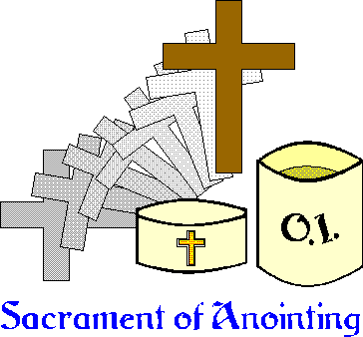
Anointing of the Sick

Follow the directions and fill in the blanks to find out what the message says below.

1. The Sacrament of Extreme Unction is now called the Sacrament of the Anointing of the Sick. Put a T if this is true. Put a A if it is not.

2. The priest anoints the sick person with holy water. Put a B if this is true. Put a E if it is not.

3. Through prayer of the priest, the person’s soul receives health and strength. Put a M if this is true. Put a S if it is not.

4. This Sacrament removes venial sins. Put a P if this is true. Put a O if it is not.

5. The purpose of the Sacrament is to revive the sick person into awareness that he is not alone, God is with him. Put a T if it is true. Put a L if it is not.

6. We should prepare for the Sacrament of Anointing of the Sick by making a good Confession. Put a A if it is true. Put a U if it is not.

7. Family members should call a priest when someone is seriously ill, even if he is not in danger of death. Put a T if this is true. Put a B if it is not.

8. This Sacrament takes away mortal sin if the person is unconscious and has made an Act of Contrition (perfect of imperfect) after sinning. Put a I if this is true. Put a F if it is not.

9. If a person dies suddenly, the priest is not allowed to give absolution and the Sacrament of Anointing to the Sick. Put a C if this is true. Put a O if this is not.

10. If the person is conscious, he receives three Sacraments in this order: 1) Confession, 2) Anointing of the Sick, and 3) the Holy Eucharist. Put a N if this is true. Put a T if it is not.

An effect of the Sacrament of Anointing the Sick is comfort in sickness and strength

against ___ ___ ___ ___ ___ ___ ___ ___ ___ ___.
1 2 3 4 5 6 7 8 9 10

